Lab 15: SDK and CLI Interactions
• Objective: Use the AWS CLI to Create an S3 bucket, configure permissions, and upload/download files to/from the bucket. Enable versioning and logging for the bucket.

Create an s3 bucket
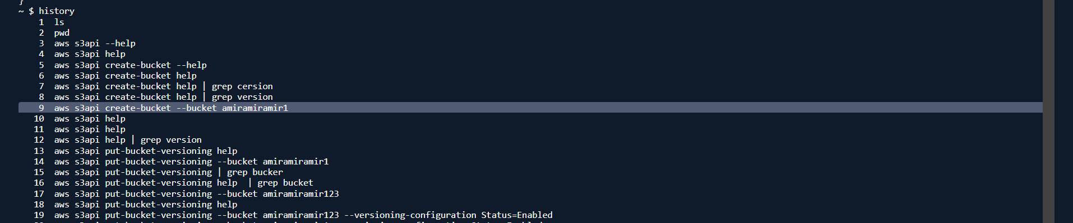

Create a permissions file and configure permissions
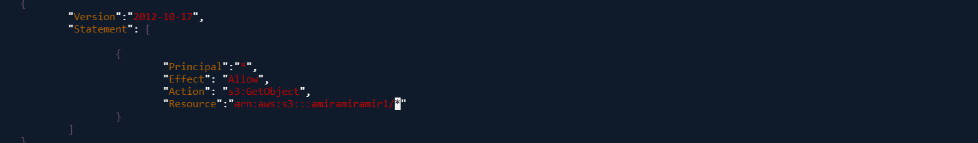

Add the permissions to s3

It gives error because public policies are block -> need to delete this block
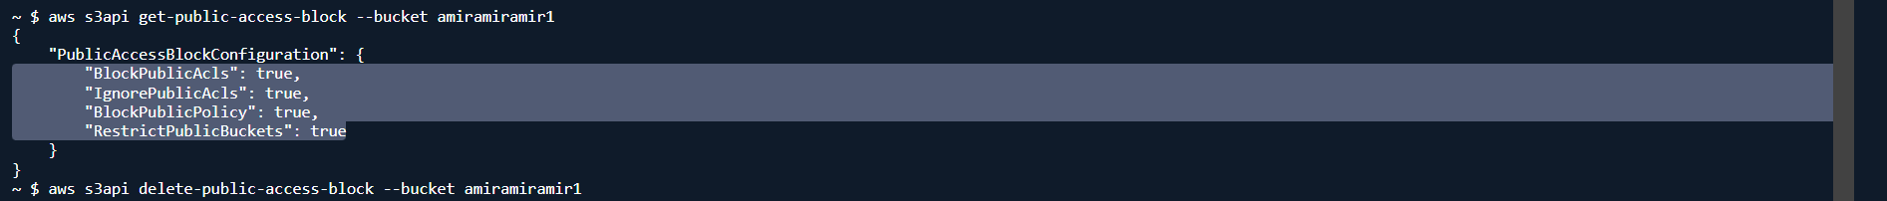

I’ve attached the policy to the bucket
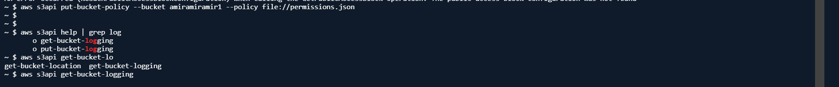

Get the logging status and change it to log in the same bucket on a preifx
